Problem Description

Traumatic spinal cord injury (SCI) is a debilitating neurological condition with severe socioeconomic impact on the health care system. Since 2015, about 30% of persons with SCI are re-hospitalized for disease of the skin, or respiratory, digestive circulatory, and musculoskeletal diseases[1]. There are approximatively 54 new cases of SCI per one million people (17,730 new cases)[2]. The injured individuals are predominantly male. The age distribution is bimodal with a first peak involving young adults and a second peak for adults over the age of 60. Injuries in this last group, usually result from falls and these patients have worst outcomes than younger patients. More than 90% of SCI cases are traumatic such as traffic accidents, violence, sports or falls (**Figure 1** below). Incomplete tetraplegia is the most frequent neurological outcome (**Figure 2** below). The estimated lifetime costs average 1 to 5 million per individual[3].

|  |
| --- |
| **Figure 1: Cause** |
|  |
| **Figure 2: Neurological Level** |
|  |

Source: National spinal cord injury statistical center

SCI are mostly contusion (49% of cases), or lacerations (21%) cases. Compression shows no breach or disruption in the surface anatomy, and presents areas of hemorrhage and necrosis. In contrast, laceration results in clear-cut of the spinal cord, the lesions are dominated with collagenous connective tissue. In massive compression, the cord is pulpified to a varying degree with extensive fibrous scarring(Norenberg et al.).

**Figure 3: “The Pathology of Human Spinal Cord Injury: Defining the Problems”**

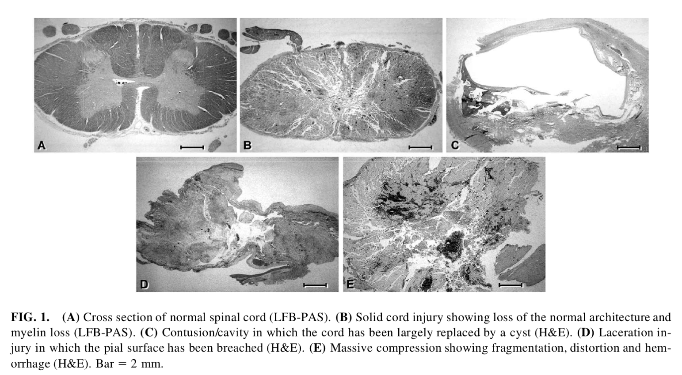

The initial primary injury causes neuronal death (axons and oligodendrocytes), increase in the level of pro-inflammatory cytokines, and recruits inflammatory cells, such as macrophages, neutrophils and lymphocytes in the spinal cord, demyelination, ischemia and hypoxia. This process persists for weeks and initiates a second wave of apoptosis in neurons and oligodendrocytes. In the late phase (weeks to months/years), the injured tissue is isolated from the environment by reactive astrocytes through the formation of a mesenchymal scar. This phase is also characterized by developments of cysts, and syrinx, and Schwannosis (Norenberg et al.) (**s** below).

|  |  |
| --- | --- |
| **Figure 4: Norenberg et al.**  **Pathophysiology of traumatic. SCI** | **Figure 5: (Desai et al.)**  **Main cellular targets of cell therapy in SCI** |
|  |  |

Motivation

According to Coherent Market Insight, the spinal cord injury therapeutic market is estimated to be valued at USD 6.7 million in 2021 and is expected to have a compound annual growth rate (CAGR) of 5.1% to reach USD 9.6 million in 2028. North America represents the largest market with 42.1%.

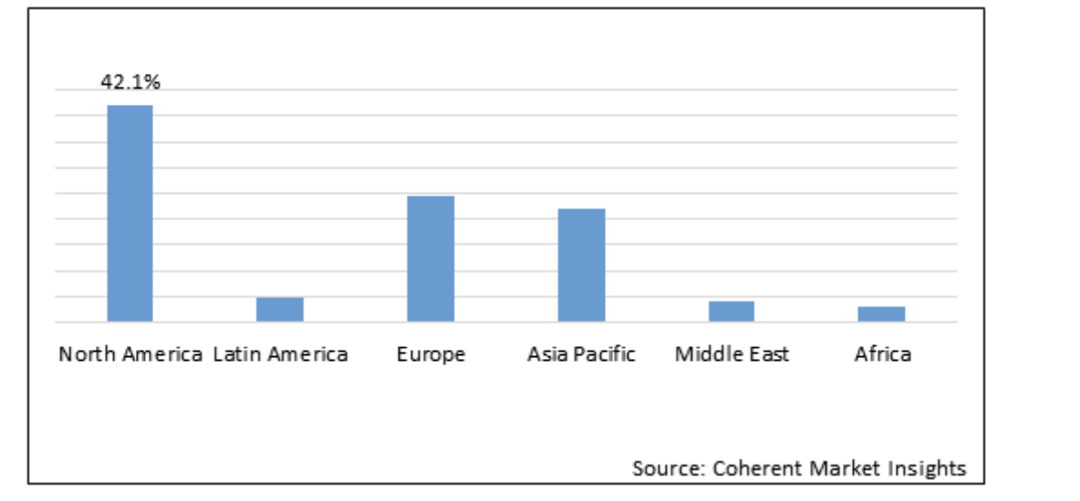

Neuro-Spinal graft targets patients who have suffered a thoracic AIS (American Spinal Injury Association Impairment scale) A traumatic spinal cord injury at neurological level of injury of T2-T12. Compared to a neurological “incomplete” injury (AIS-B, C or D), AIS-A has the least potential improvement, the lowest lifetime survival (Dukes et al.)(**Figure 6** below). In term of costs, Medicaid is the only national program covering services that SCI survivors require. Mean annual cost oof hospitalization are the highest among persons with AIS-A, AIS-B, or AIS-C injuries with a daily cost of $2601 (2015 US$) (Dukes et al.) (**Figure 7** below).

|  |  |  |
| --- | --- | --- |
| **Figure 6: ASIA Impairment Scale Grade** | **Figure 7: Estimated lifetime expectancy** | |
|  | |  |

**References**:

1. Desai, Jyaysi, et al. “Molecular Pathophysiology of Gout.” *Trends in Molecular Medicine*, vol. 23, no. 8, Aug. 2017, pp. 756–68. *DOI.org (Crossref)*, https://doi.org/10.1016/j.molmed.2017.06.005.
2. Dukes, Ellen M., et al. “Relationship of American Spinal Injury Association Impairment Scale Grade to Post-Injury Hospitalization and Costs in Thoracic Spinal Cord Injury.” *Neurosurgery*, vol. 83, no. 3, Sept. 2018, pp. 445–51. *PubMed Central*, https://doi.org/10.1093/neuros/nyx425.
3. Norenberg, Michael D., et al. “The Pathology of Human Spinal Cord Injury: Defining the Problems.” *Journal of Neurotrauma*, vol. 21, no. 4, Apr. 2004, pp. 429–40. *DOI.org (Crossref)*, https://doi.org/10.1089/089771504323004575.

1. National spinal cord injury statistical center.
2. Jain NB, Ayers GD, Peterson EN, et al. Traumatic spinal cord injury in the United States, 1993-2012. JAMA. 2015;313(22):2236-2243.
3. Economic Impact of SCI published in the journal Topics in Spinal Cord Injury Rehabilitation, Volume 16, Number 4, in 2011.